**Cholera Outbreak in Stockholm, 1853**

**Introduction**

The cholera outbreak of 1853 in Stockholm represents a significant event in the city's 19th-century history, reflecting the broader societal impacts of pandemics in urban environments with poor sanitation. This report delves into the outbreak, focusing on the detailed data preserved in church archives and official records, and aims to provide insights into the epidemic's progression and its traumatic effects on society.

**Historical Context**

In the mid-19th century, Stockholm faced several public health challenges, with cholera being one of the most devastating. The outbreak in late August 1853 resulted in the deaths of approximately 3% of the population within a few weeks. The impoverished areas, particularly S

Catherine parish, were severely affected due to their inadequate sanitation facilities.

**Data Collection**

The data is collected from hand-written church records. The church was responsible for all population registration until around 1870. Only death records have been analyzed. Since Cholera has around 40% CFR, we can assume a larger number of affected but surviving individuals.

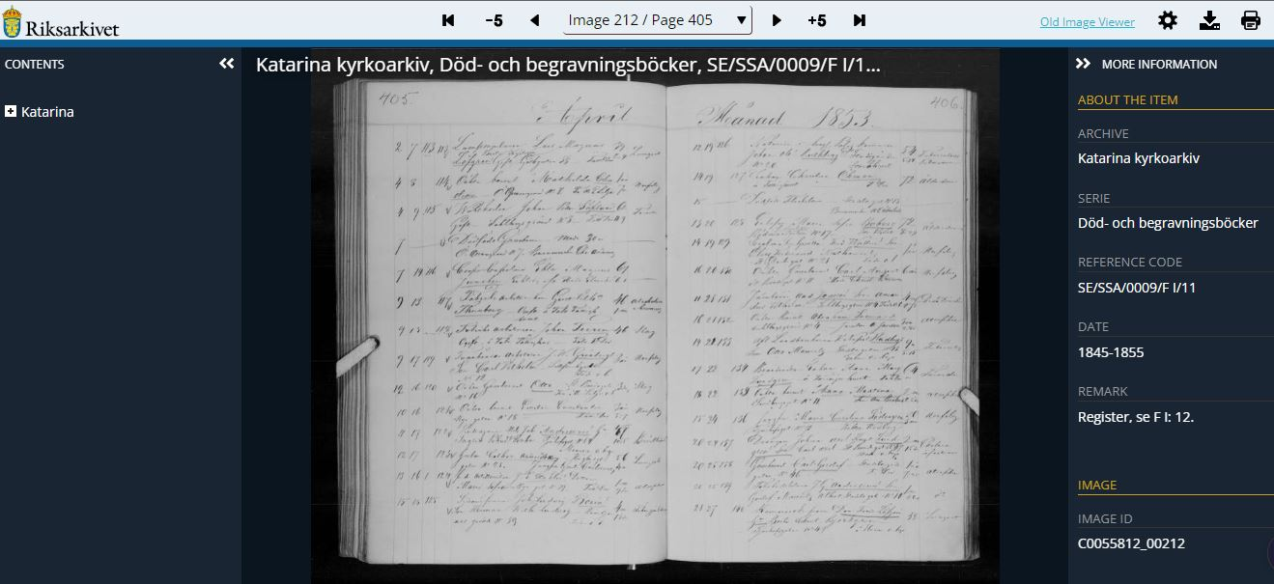

The primary sources of data for this research are the well-preserved church records and official reports. it is inferred that a significant number of individuals were affected but survived. A notable document from the church records during the peak of the outbreak in September can be viewed here:

**Data Preparation:**

Digitizing Hand-Written Records:

Transcribe the hand-written church records into a digital format for analysis. This involves manually entering data into a spreadsheet or database.

Key data points include dates of death, age, gender, occupation, and location (parish).

**Data Cleaning:**

**Unclean data**

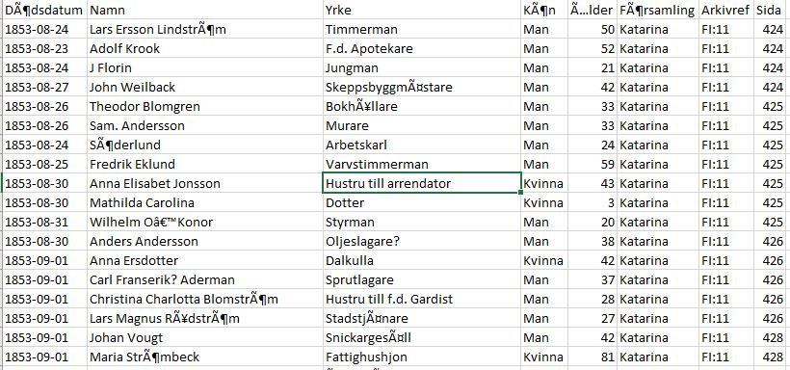

**Step 1**

Translate the language from Swedish to English using spreadsheet function

=Google translate (Text, [source language], [target language])

Google Language Code = Swedish (Sv) to English(en)

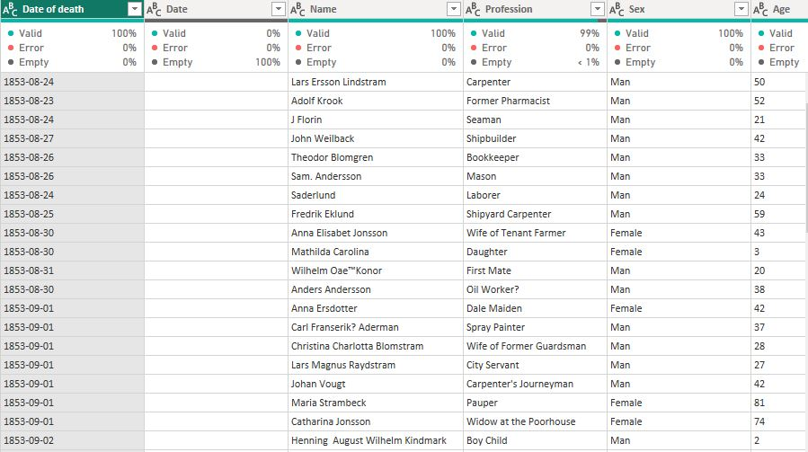

Step 2

Standardize formats (e.g., dates, names).

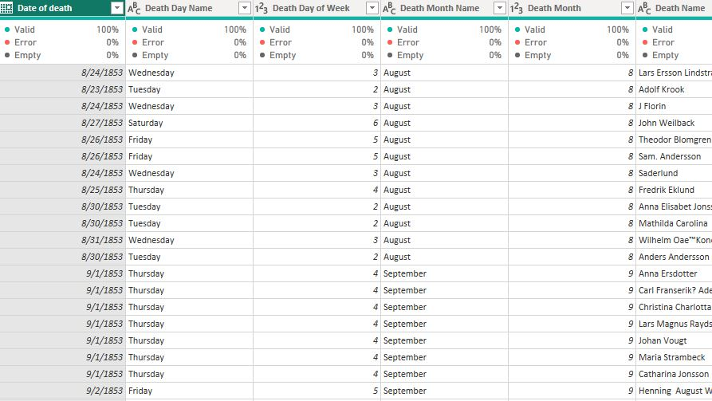

Working on changing the date format (from text to date to ate year, day of the week, Month, Month name)

**Step 4:** Initial Data Analysis

**Descriptive Statistics:**

This deal with the collecting ,organizating,summarizing, and presenting data

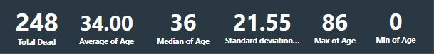

Calculate basic statistics such as total deaths, Average Age, daily death rates, and demographic breakdowns (age, gender, etc.).

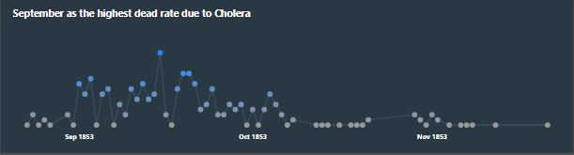

Identify patterns in the data, such as peak periods of mortality.

**1. Mortality Analysis:**

Compare mortality rates across gender, demographics and Profession.

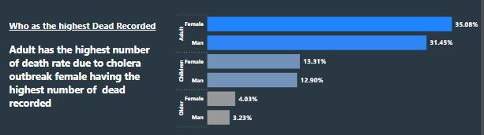

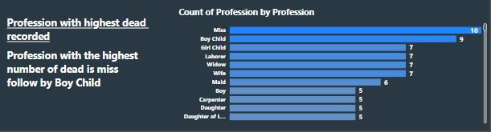

**Summarize Findings:**

* key findings from the analysis, in 1853 with 3month (sep, oct, Nov) 248 total death was recorded. Peak mortality periods are September, Female having the highest death rate of 52.43% (F) and Male having death rate of 47.82%.
* Adult and children are mostly affected.
* Miss and Boy child has the highest dead rata by Profession.

**External findings:**

**What was the cause of the cholera outbreak**

* There were theories that the epidemics were affected by poor hygiene as at that time people don’t know the cause of cholera.
* In this period, the latrine and waste systems in Stockholm were handled by private entrepreneurs and were in very bad condition, and the drinking water was not filtered.

**Policy Implications**:

* Government taking full responsibility of the system and keep on improving it.
* Stockholm inaugurated its own central system for tending to the latrine and waste of the city, which radically improved the hygiene in Stockholm.